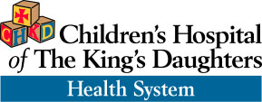

**Children’s Surgical Specialty Group - Pediatric Surgery-Nuss Center**

**PROTOCOL FOR PULMONARY FUNCTION STUDIES WHEN EVALUATION FOR PECTUS EXCAVATUM**

Pulmonary function studies should include pre and post bronchodilator, spirometry with MVV, plethysmography, and an oxygen saturation check. The studies should ideally have been done within the last year. When sending the results, make sure that the interpretation is included.

Please contact call us with any further questions at the Nuss Center 757-668-6877 or you can email us at [pectus@chkd.org](mailto:pectus@chkd.org).