**Healthy You For Life Spring 2018 Newsletter**

[](http://www.google.com/url?sa=i&rct=j&q=&esrc=s&source=images&cd=&cad=rja&uact=8&ved=2ahUKEwihvvv5rcbaAhUImeAKHczcB8AQjRx6BAgAEAU&url=http%3A%2F%2Fclipart-library.com%2Ffree-spring-cliparts.html&psig=AOvVaw0ztnTjCmcJtNYZK87skiFQ&ust=1524228008344225)

**How Do Your Snacks Stack Up?**

Snacks play an important role in the growth and development of children. A growing child needs 1-2 snacks each day to keep their bodies fueled and ready to move. Unfortunately, so many of the snacks advertised for children are full of sugar, salt, and fat - all of which can make it hard to maintain energy levels and achieve healthy living goals. When hunger strikes and kids (or parents!) open the pantry to shelves full of crackers, chips, cookies, pretzels, fruit snacks and granola bars, it is difficult to make a healthier choice. As we begin spring cleaning, consider "cleaning out" the snacks in your home and stocking up on healthier whole foods for the family.

Snacks are not just filler food between meals, they are essential in a healthy lifestyle, so try to make the most of them. Snacks should be satisfying (to keep you from munching all day), but they should not be full plates of food. A good snack should include foods from 2 different food groups. Most people aren't getting enough fruits and vegetables, so be sure to choose one of these as part of your snack. Using MyPlate as your guide? Think about which food groups you missed at breakfast or lunch and use your afternoon snack as a time to play catch up.

Healthy Whole Food Snacks by Food Group:

**Vegetables:** carrot sticks or raw veggie tray with hummus or ranch dressing, ants on a log (celery filled with peanut butter and topped with raisins), guacamole with homemade chips (cut a corn or whole wheat tortilla into triangles, spray lightly with cooking spray, bake at 350 degrees for 10-12 minutes)

**Fruit:** whole fruits (You name it! try to avoid fruit sauces and juices), sprinkle cinnamon on apple slices or pair fresh fruit with slices of cheese for a yummy snack, frozen fruit is a fun treat on a hot day

**Protein:** unsalted or lightly salted nuts (mix with dried fruit and whole grain cereal to make your own trail mix), sunflower seeds or pumpkin seeds, hard boiled eggs, leftover grilled or baked meats (portion sizes for snacks are smaller than meals)

**Whole Grains:** whole wheat or whole grain bread - try it toasted with a small amount of nut butter for a protein kick, mini pizzas (spread tomato sauce on a whole wheat English muffin, sprinkle with cheese, and warm up in the oven or toaster oven until the cheese melts), popcorn - make it yourself with no added salt or fat by putting plain kernels in a brown paper lunch bag and microwaving for 3-4 minutes

**Dairy:** low fat cheese sticks or cubes, Greek yogurt (avoid extra sugary "kid" yogurts or anything with candy pieces)

Tips for successful snacking:

* Sit down as a family and make a list of healthy foods you enjoy! Include fruits, vegetables, proteins, whole grains, and dairy foods. Keep this list posted inside a kitchen cabinet so you can look at it and add foods whenever you need to.
* Make a "weekly menu" of healthy snacks that are available at home that week and post it on the fridge or pantry door to help kids think about their choice before they start looking.

**How to Grow Vegetables in a 5 Gallon Bucket**

Short on growing space but still yearn for homegrown [tomatoes](http://www.seedsnow.com/collections/shop-tomato-seeds) and [peppers](http://www.seedsnow.com/collections/shop-hot-spicy-pepper-seeds)? Is your garden located on a balcony or terrace and you’re afraid you can’t savor the taste of vine ripened tomatoes or experience the heat of your favorite variety of pepper? Well you can, and all you need is a 5 gallon bucket, nutrient rich soil, a few amendments, water and your favorite variety of [heirloom seeds](http://www.seedsnow.com/) or seedlings.

* 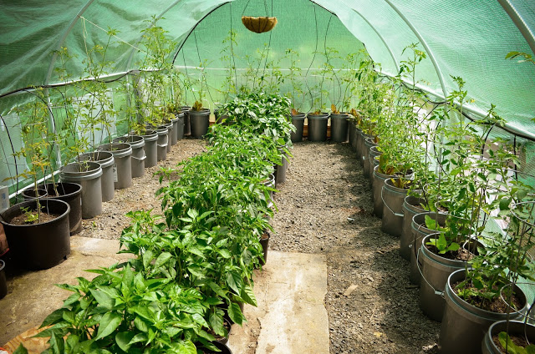Start by finding a 5 gallon bucket. Make sure it is clean and food grade, meaning there’s never been any nasty chemicals stored or shipped in your container.   Usually you can acquire these by visiting your local bakery or even a trip to the hardware store will lead you to a simple 5-gallon bucket. Generally they can be purchased at your big-box hardware stores for around $4.00.
* Once your bucket is clean, fill it with nutrient rich soil.  If you have your own compost, add some of that. Always use rich organic soil.
* For best results, especially in climates that are a little cooler, try starting your tomato and pepper plants indoors 6-8 weeks before your last average frost date.  Tomatoes and peppers do well with [transplanting](http://www.seedsnow.com/pages/getting-started-transplanting) and rarely experience “shock” once they are moved from their indoor locations out into their permanent home in the garden.
* Add your nutrient dense soil into your 5 gallon bucket. Dig a hole deep enough for you to plant your seedlings and then add a small amount of vegetable or tomato plant food at the bottom of each hole.  Give the soil a light water with a watering can.
* Place your tomato plant inside the hole and then fill the surrounding area with soil.  Remember that you can bury your tomato plants extra deep, up to their first set of true leaves. This long “stem” that you’re burying into the soil will actually help the tomato plant develop a strong root system. So bury those tomatoes deep! They love it.
* 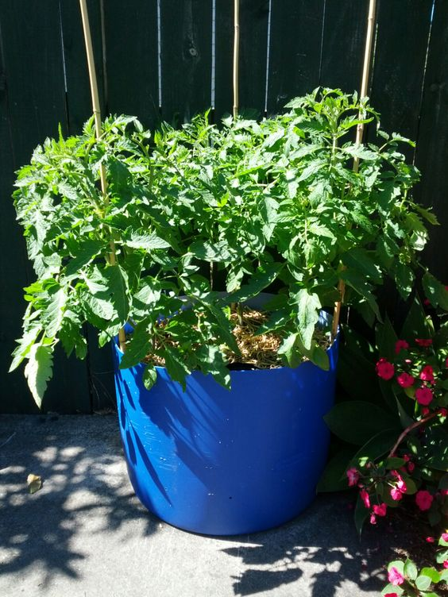Once your tomato and pepper plants have been put into the soil, give the entire bucket a good [water](http://www.seedsnow.com/pages/getting-started-watering)ing.
* To help keep weeds down in your container, spread a thin layer of [mulch](http://www.seedsnow.com/pages/getting-started-mulch) on top of the soil. This will also help keep the soil moist and from drying out too quickly. Soil in containers will dry out sooner than if they are planted directly into the ground, so keep an eye on them. Peppers don’t mind soil that is slightly dryer, once the plant is established but your tomatoes will need regular watering. Water plants until water starts to drain out of the holes in the bottom of the bucket. Too much, or too little watering will result in cracked tomatoes, or blossom end rot, once they have reached maturity.
* Tomatoes and peppers both love the sun and the heat.  Keep your buckets in a sunny location.
* Try planting companion plants near your buckets such as: [marigolds](http://www.seedsnow.com/products/marigold-crackerjack-mix), [basil](http://www.seedsnow.com/collections/basil-seeds), [borage](http://www.seedsnow.com/products/borage), [chives](http://www.seedsnow.com/collections/grow-your-own-chives), calendula, and [carrots](http://www.seedsnow.com/collections/shop-carrot-seeds).  Avoid [fertilizing](http://www.seedsnow.com/pages/getting-started-fertilizers) with too much nitrogen. This encourages leafy growth instead of flowering…and the flowers are what will produce the fruit. Try time-released fertilizers so that the nutrients won’t all be washed away with frequent watering.

[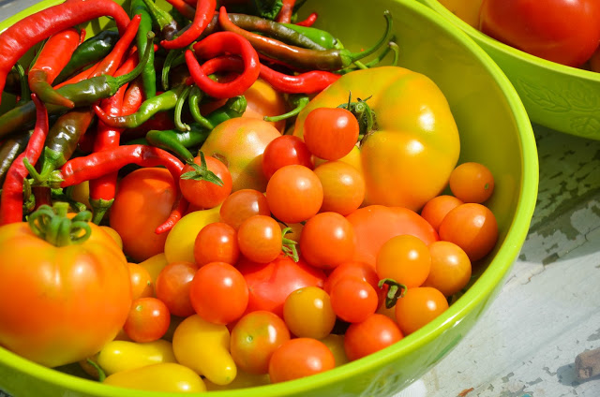](http://www.urbanorganicgardener.com/wp-content/uploads/2015/04/DSC_5004.jpg)

**Fresh Tomato Salsa**

3 large tomatoes, seeded and chopped (3 cups)

1 small green bell pepper, chopped (1/2 cup)

3 garlic cloves, finely chopped

8 medium green onions, sliced (1/2 cup)

2 tablespoons chopped fresh cilantro (optional)

1 tablespoon finely chopped jalapeno chili

2-3 tablespoons lime juice

1/2 teaspoon salt

1. Mix all ingredients in a bowl.
2. Cover and refrigerate until serving.

**Homemade Whole Wheat Tortilla Chips**

5 (8-10 inch) whole wheat tortillas

non-stick cooking spray (Healthy You recommends olive oil or canola oil)

1. Preheat oven to 375o.
2. Cut each tortilla into 6 triangle shapes.
3. Coat a baking sheet with non-stick cooking spray.
4. Place tortila pieces on baking sheet. Lightly spray with cooking spray.
5. Bake until golden brown and crispy, about 8-10 minutes.