Healthy You For Life Winter 2018 Newsletter

With the New Year upon us, many people have started working on resolutions to improve their health and wellbeing. The team here at Healthy You For Life would like to encourage you to focus on taking care of your mental health, and boosting your own self esteem. Feeling good about yourself can help you succeed. Whether it's getting good grades, making friends, or achieving better health - feeling good about yourself can make it all easier. Building confidence starts with respecting and loving yourself. Having good self esteem takes effort, but it can be well worth the time you put in. Here are 5 tips to help you improve the way you feel about yourself:
1. Believe in yourself! Start with small, realistic goals. Achieving a small task can boost confidence. Once you've achieved a goal, set your sights on the next step.
2. Forgive yourself! Don't feel bad if you slip up on one of your goals, or make a mistake at school or with friends. Figure out what went wrong, and try to do better next time. Don't be afraid to ask for help when you need it.
3. Eat 3 meals a day. Consuming well balanced meals, throughout the day can help your body feel energized and healthy. Not sure what counts as a well balanced meal? Use MyPlate as a guide to help you get all the food groups your body needs.
4. Get moving every day! Walking outside in the fresh air or doing some indoor exercises can help you deal with stress and feel good about yourself.
5. Be kind to yourself. Spend 15-30 minutes to de-stress every day. Go for a walk, talk with a friend, read a book, dance, or do something that makes you happy. Try taking 2 minutes each day to write down 3 things you appreciate about yourself.


Do food dyes effect children's behavior?
Many people know that we need to watch out for extra sugar, fat or sodium in our food, but have you ever stopped to think about the different food dyes we eat? Many foods marketed to children contain brightly colored food dyes, but some colored foods can pose a health risk.
Dyes in foods such as cakes, pop tarts, Cheetos, M&M's, gummies or a glass of Kool-Aid can affect children's behavior and learning, increasing ADHD symptoms in many children. Dyes are added to foods such as blueberry muffins, breakfast cereals, or fruit flavored drinks to make consumers think that there is real fruit in their food instead of chemicals. Many of these foods also contain extra added sugars and sodium. While many food dyes have been banned in Europe, children in the US are frequently offered foods containing dyes that may cause behavior issues. The Center For Science In The Public Interest is recommending that US companies stop putting chemical dyes in our food, but little is expected to change in the near future.
If you are concerned about the food dyes you and your family are eating, take a look at the black and white food labels on things you have at home. Cutting out foods and drinks that contain chemical dyes (such as Red 40, Yellow 5, and Yellow 6) may make a big difference on how you feel.
To learn more about food dyes, take a look at the website for the Center For Science In The Public Interest, https://cspinet.org.

Want to replace some of your snacks that contain food dye? Whole foods (fruits, veggies, nuts, etc.) are great, but try this list of dye free snack foods:
Kashi granola bars
Teddy Grahams
Annie's Bunny Grahams
Stauffer's Animal Crackers (not frosted)
UNREAL candies
Pirate’s Booty white cheddar puffs
Cheerios (all varieties)
Honest Kids juice drinks
Crystal Light drink mixes
A fun idea from our exercise specialists...May the Fitness be with You!
The Fitness Awakens - A Star Wars-Themed Fitness Circuit
Turn on the Star Wars theme song and try out this exercise circuit:
1. Luke Skywalker Planks – From a standing position, bring both hands down to the floor and 'walk out' into a floor plank. Walk hands back toward feet and return to a standing position.
2. Jedi Jumps – Squat down low and jump up high with both hands extended to the sky.
3. Princess Leia Lunges – Alternate lunges going both forward and backward.
4. Chewbacca Chops – Standing with your feet wide, extend both hands over your right shoulder and chop your hands down towards your left foot. Bring your hands back up to start. Be sure to switch sides.
5. BB-8 Rolls – Standing with your feet wide and your hands at your chest, begin to bend your knees and curl into a bowl by bringing your elbows to your knees. Inhale to stand back up and exhale to curl back in.
6. R2-D2 Shakes – Standing with your feet shoulder-width apart and your palms pressed against your sides, rock back and forth by picking up one foot and then the other. Make robot beeps!
7. Rey Runs – Jog in place. Change your speed like you're running from the Empire!
8. Darth Vader Jumps – With both feet together, jump to face the 'dark side' (to face the other direction) and then jump back again (facing where you started) to return as a Jedi.
9. Jyn Jabs – Standing with your feet shoulder-width apart and knees slightly bent, curl your hands into fists in front of your face. Then, pretend to be a boxer, alternating arm punches for an upper body workout.
10. Yoda Mindfulness – Close your eyes and stand tall, taking 5-7 deep breathes in through your nose and out through your mouth.
http://www.actionforhealthykids.org/game-on/1839

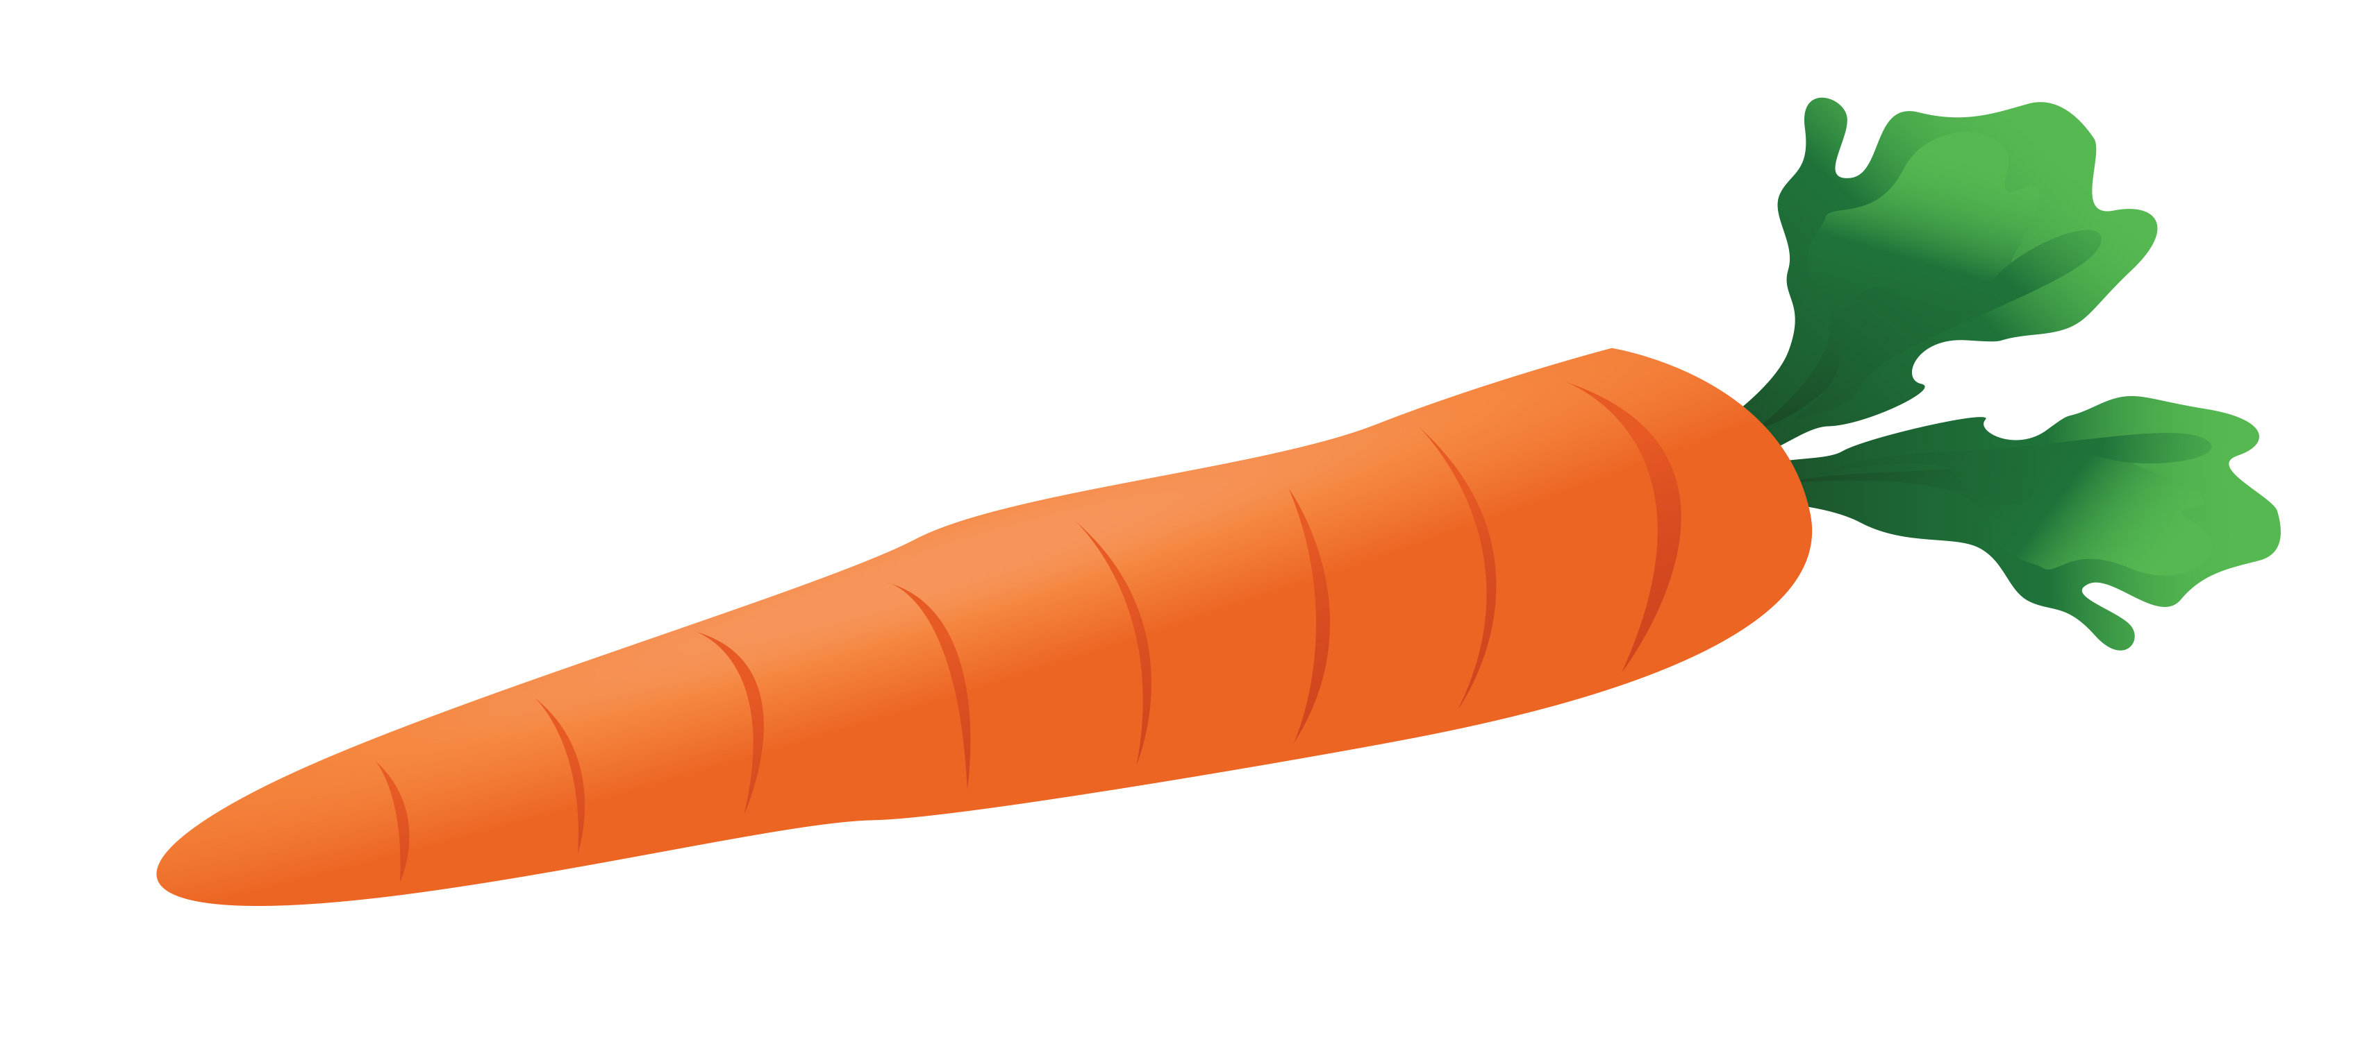
During the cooler winter months, roasting vegetables in the oven is an easy and delicious way to fill half your plate. Roasting can bring out the richer, sweeter taste of many vegetables. Cutting vegetables into smaller pieces will help them cook faster. Try this guide with whatever your favorite veggies are:
- Preheat oven to 375-425 degrees (higher temp will cook faster).
- Wash and cut vegetables into 1-2 inch pieces (good roasting vegetables include asparagus, beets, broccoli, brussels sprouts, carrots, cauliflower, green beans, onions, parsnips, peppers, and squash). Plan on about 2 cups of chopped veggies per person, as they will shrink when cooked.
- Sprinkle with 1-2 Tablespoons olive or canola oil. Sprinkle with herbs, salt, and pepper (whatever you like!).
- Place on a baking sheet in the middle of the oven. Set timer for 10 minutes. After 10 minutes, turn the veggies and cook for another 5-10 minutes.

